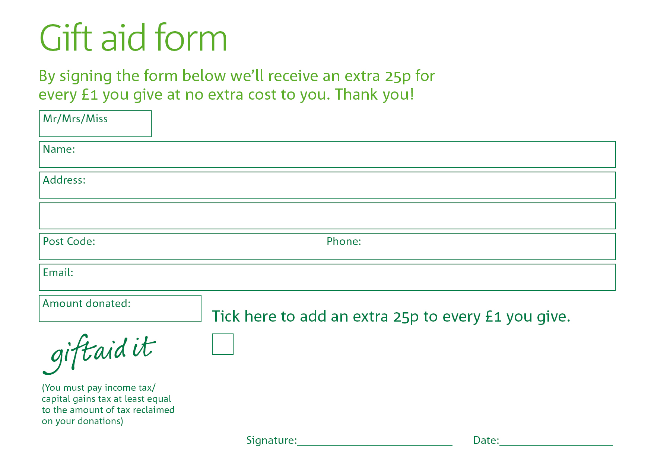
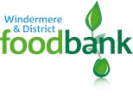

Yes, I pay tax in the UK. Please treat all donations I make or have made to the Windermere Foodbank for the past four years and for the future as gift aid donations until further notice. I understand that if I pay less Income and /or Capital Gains tax than the amount of Git Aid claimed on all my donations in that tax year, it is my responsibility to pay any difference.

Windermere Foodbank is committed to protecting your privacy and will process your personal data in accordance with current Data Protection legislation. Windermere Foodbank collects information to keep in touch with you and supply you with information relating to our work. To unsubscribe from our newsletter, send an message to the email address above with the word ‘unsubscribe’ in the subject line. A full data privacy statement for financial donors is available from the foodbank on request.
Yes, I pay tax in the UK. Please treat all donations I make or have made to the Windermere Foodbank for the past four years and for the future as gift aid donations until further notice. I understand that if I pay less Income and /or Capital Gains tax than the amount of Git Aid claimed on all my donations in that tax year, it is my responsibility to pay any difference

